There are three most common relationships among classes in Java that are as follows:
a. Dependence (“Uses-A”)
b. Association (“Has-A”)
c. Inheritance (“Is-A”)
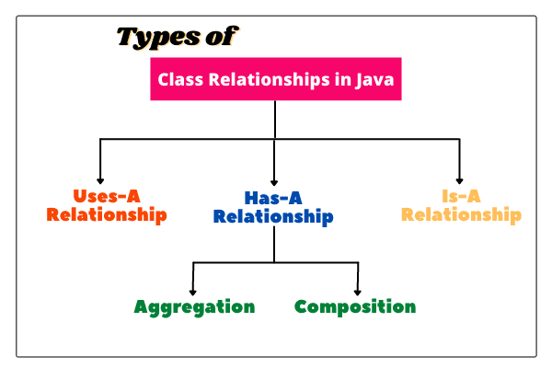
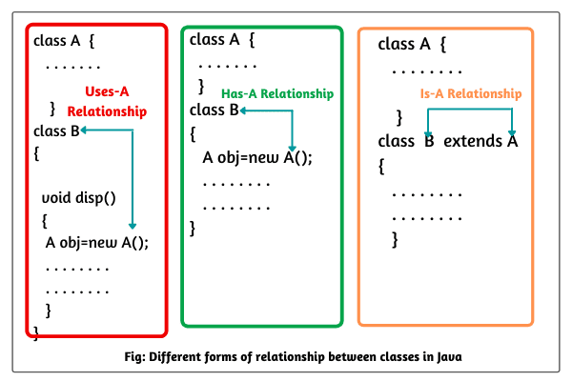

Dependence (Uses-A) Relationship in Java:
When we create an object of a class inside a method of another class, this relationship is called the dependence relationship in Java, or simply the Uses-A relationship.
In other words, when a method of a class uses an object of another class, it is called dependency in java. It is the most obvious and most general relationship in java.
Note:
If several classes of an application program depend on each other, then we say that the coupling between classes is high.
It is a good programming practice to minimize the dependency between classes (i.e., coupling) because too many dependencies make an application program difficult to manage.
On the other hand, if there are few dependencies between classes, then we say that the coupling between classes is low.
Why does coupling matter?
If a class changes its behaviour in the next release of the application program, all the classes that depend on it may also be affected. In this situation, we will need to update all the coupled classes.
Therefore, if the coupling between classes will be low, we can easily manage them. Thus, we must remove unnecessary coupling between classes.

Association (“Has-A”) Relationship in Java
Association is another fundamental relationship between classes that is informally known as the “Has-A” relationship.
When an object of one class is created as a data member inside another class, it is called association relationship in java or simply Has-A relationship.
Look at the above figure where an object of class A is created as a data member inside another class B. This relationship is known as the Has-A relationship. It is easy to understand and makes a stronger form of dependency.

Inheritance (“Is-A”) Relationship in Java
Inheritance represents Is-a relationship in Java. It establishes a relationship between a more general class (known as a super class) and a more specialized class (known as subclass).
In other words, Is-A relationship defines the relationship between two classes in which one class extends another class.

Designing a Domain Model
The Domain Model is your organized and structured knowledge of the problem. The Domain Model should represent the vocabulary and key concepts of the problem domain and it should identify the relationships among all of the entities within the scope of the domain.
It helps you understand the complexity of the domain. For the domain model for each Bounded Context, you identify and define the entities, value objects, and aggregates that model your domain. You build and refine a domain model that is contained within a boundary that defines your context.
Example 1: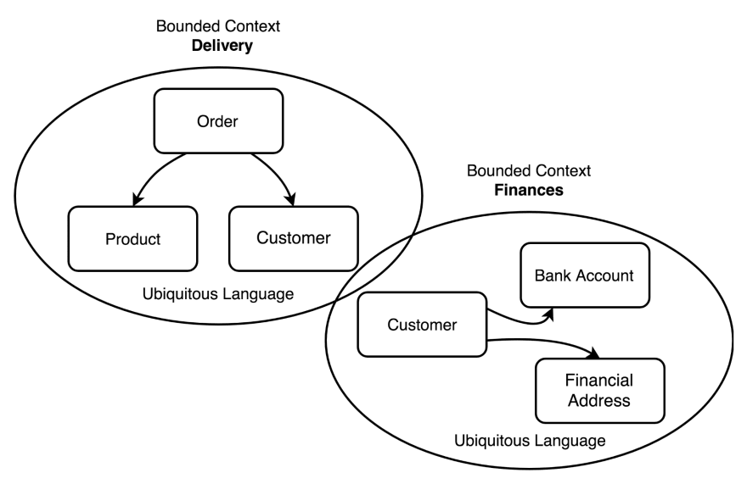
Example 2:
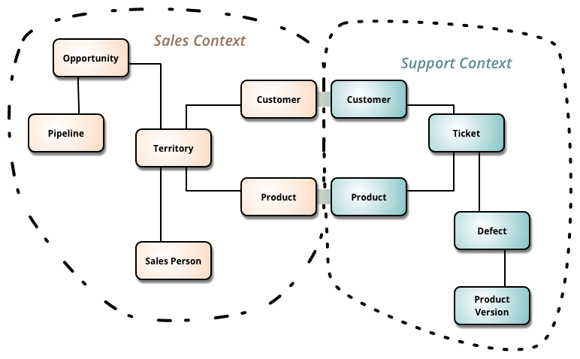s

